English Language Arts Component of the NJGPA
Computer-Based Practice Test Answer and Alignment Document

Unit 1
Items 1‐7
Task: Literary Analysis Task (LAT)
Passage 1: from "Red Cranes" by Jacey Choy
Item  Number | Answer(s) | Standards  Alignment
1 | Item Type: EBSR  Part A: A  Part B: C | RL1; RL4
2 | Item Type: EBSR  Part A: B  Part B: D | RL1; RL3
3 | Item Type: EBSR  Part A: C Part B: D | RL1; RL3
Passage 2: from "The Firefly Hunt" by Jun’ichiro Tanizaki
4 | Item Type: TECR Part A: B  Part B: | RL1; RL4; L6
5 | Item Type: EBSR Part A: A  Part B: D | RL1; RL2;
6 | Item Type: TECR Part A: C  Part B:  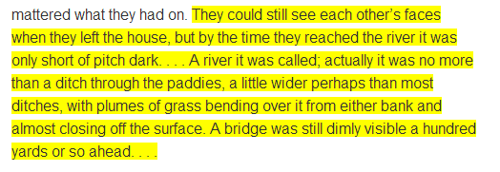 | RL1; RL5
Passage 1: from “Red Cranes” by Jacey Choy and
Passage 2: from “The Firefly Hunt” by Jun’ichiro Tanizaki
7 | Item Type: PCR  Refer to Grades 6–High School Scoring Rubric for Prose Constructed Response Items | RL1; RL3; RL6; W2;  W4‐10
Items 8‐11
Passage Type: Informational S/M
Passage: “10 Things You Can Do to Avoid Fraud” by Federal Trade Commission

Item  Number | Answer(s) | Standards  Alignment
8 | Item Type: EBSR  Part A: D  Part B: B | RI1; RI4;  L4
9 | Item Type: EBSR  Part A: B Part B: B | RI1; RI2;  RI3
10 | Item Type: EBSR  Part A: A  Part B: D and E | RI1; RI3;  RI5; RI6
11 | Item Type: EBSR  Part A: B  Part B: D | RI1; RI2;  RI6

Unit 2
Items 1‐9
Task: Research Simulation Task (RST)
Passage 1: “Tinker v. Des Moines Independent Community School District” majority opinion by Justice Abe Fortas
Item  Number | Answer(s) | Standards  Alignment
1 | Item Type: EBSR Part A: C  Part B: B and C | RI1; RI2
2 | Item Type: EBSR Part A: D  Part B: C | RI1; RI5; RI6
Passage 2: “Tinker v. Des Moines Independent Community School District” dissenting opinion by Justice Hugo Black
3 | Item Type: EBSR  Part A: D  Part B: A | RI1; L4
4 | Item Type: EBSR  Part A: C Part B: A | RI1; RI6

Passage 1: “Tinker v. Des Moines Independent Community School District” majority opinion by Justice Abe Fortas and
Passage 2: “Tinker v. Des Moines Independent Community School District” dissenting opinion by Justice Hugo Black
5 | Item Type: TECR  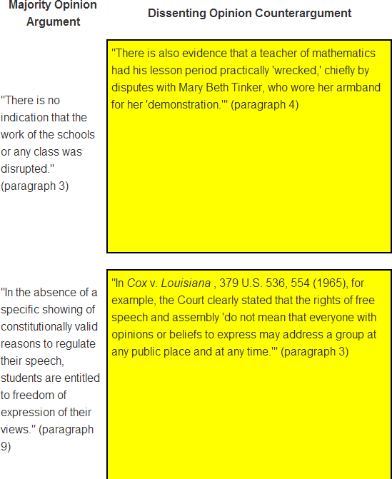 | RI1; RI9
6 | Item Type:  EBSR  Part A: D Part B: C | RI1; RI5; RI9
Passage 3: Audio clip of interview with law professor Catherine Ross on the Tinker v. Des Moines court decision
7 | Item Type: EBSR Part A: B  Part B: C | RI1; L4
Passage 1: “Tinker v. Des Moines Independent Community School District” majority opinion by Justice Abe Fortas and
Passage 3: Audio clip of interview with law professor Catherine Ross on the Tinker v. Des Moines court decision
8 | Item Type: EBSR  Part A: A Part B: D | RI1; RI2;  RI9
Passage 1: “Tinker v. Des Moines Independent Community School District” majority opinion by Justice Abe Fortas,
Passage 2: “Tinker v. Des Moines Independent Community School District” dissenting opinion by Justice Hugo Black, and
Passage 3: Audio clip of interview with law professor Catherine Ross on the Tinker v. Des Moines court decision
9 | Item Type: PCR  Refer to Grades 6–High School Scoring Rubric for Prose Constructed Response Items | RI1; RI3;  RI9; W2;  W4‐10

